ASSIGNMENT – 5

Q1. Write a program that creates a class Account that have members customer name, account number. Account has constructor to initialize its members and method display() to show the result. Create a child class Savings_Account that is derived from Account class. Savings_Account have members min_bal and saving_bal. Use show() to display its details. Then create another child class Account_details from Savings_Account class have members deposit, withdrawl and a method show1() to show its details. Child classes have constructors of their own. Create a driver class that creates a record of customer and display all its details.
Code:
import java.util.Scanner;
class BaseAccount {
String customerName;
int accountNo;
BaseAccount(String name, int number) {
this.customerName = name;
this.accountNo = number;
}
void display() {
System.out.println("Customer Name: " + customerName);
System.out.println("Account Number: " + accountNo);
}
}
class SavingsAccount extends BaseAccount {
double min_bal;
double saving_bal;
SavingsAccount(String name, int number, double min_bal, double saving_bal) {
super(name, number);
this.min_bal = min_bal;
this.saving_bal = saving_bal;
}
void show() {
super.display();
System.out.println("Minimum Balance: " + min_bal);
System.out.println("Saving Balance: " + saving_bal);
}
}
class Account_Details extends SavingsAccount {
double deposit;
double withdrawl;
Account_Details(String name, int number, double min_bal, double saving_bal,
double deposit, double withdrawl) {
super(name, number, min_bal, saving_bal);
this.deposit = deposit;
this.withdrawl = withdrawl;
}
void show1() {
super.show();
System.out.println("Deposit: " + deposit);
System.out.println("Withdrawal: " + withdrawl);
System.out.println("Final Balance: " + (saving_bal + deposit - withdrawl));
}
}
public class Account {
public static void main(String args[]) {
Scanner sc = new Scanner(System.in);
System.out.print("Enter The Name: ");
String s = sc.nextLine();
System.out.print("Enter The Account Number: ");
int a = sc.nextInt();
System.out.print("Enter The Minimum Balance: ");
double min = sc.nextDouble();
System.out.print("Enter The Savings Balance: ");
double bal = sc.nextDouble();
System.out.print("Enter The Deposit Amount: ");
double dep = sc.nextDouble();
System.out.print("Enter The Withdrawal Amount: ");
double with = sc.nextDouble();
System.out.println("\nCustomer Details ");
System.out.println("*****************");
Account_Details accdet = new Account_Details(s, a, min, bal, dep, with);
accdet.show1();
sc.close();
}
}
Output: 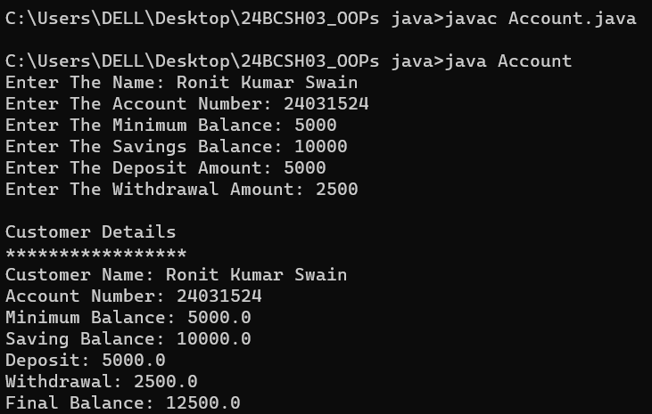

Q2. Create a class Figure with instance members dim1 and dim2. Use constructor and area() that returns the area of figure. Create a derived class Rectangle derived from Figure and area() that returns the area of rectangle. Create another derived class Triangle and Square that has area() which returns area of Triangle and Square respectively. Derived class have appropriate constructor. Using method overriding concept test the functionalities of derived class by creating objects and super class memory references in Driver class.

Code:
import java.util.Scanner;
class Figure {
double dim1, dim2;
Figure(double d1, double d2) {
this.dim1 = d1;
this.dim2 = d2;
}
double area() {
System.out.println("Area of figure is not defined.");
return 0;
}
}
class Rectangle extends Figure {
Rectangle(double length, double breadth) {
super(length, breadth);
}
@Override
double area() {
return dim1 * dim2;
}
}
class Triangle extends Figure {
Triangle(double base, double height) {
super(base, height);
}
@Override
double area() {
return 0.5 * dim1 * dim2;
}
}
class Square extends Figure {
Square(double side) {
super(side, side);
}
@Override
double area() {
return dim1 * dim1;
}
}
public class Figured {
public static void main(String[] args) {
Scanner sc = new Scanner(System.in);
Figure f;
System.out.print("Enter length of Rectangle: ");
double l = sc.nextDouble();
System.out.print("Enter breadth of Rectangle: ");
double b = sc.nextDouble();
f = new Rectangle(l, b);
System.out.println("Area of Rectangle: " + f.area());
System.out.print("\nEnter base of Triangle: ");
double base = sc.nextDouble();
System.out.print("Enter height of Triangle: ");
double h = sc.nextDouble();
f = new Triangle(base, h);
System.out.println("Area of Triangle: " + f.area());
System.out.print("\nEnter side of Square: ");
double s = sc.nextDouble();
f = new Square(s);
System.out.println("Area of Square: " + f.area());
sc.close();
}
}
Output:
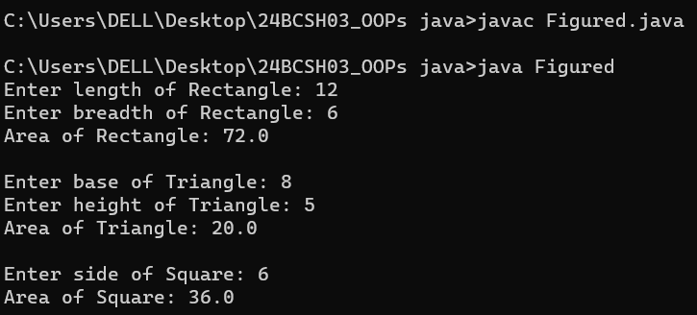

Q3. Write a program to create a class named Shape. It should contain two methods, draw() and erase() that prints “Drawing Shape” and “Erasing Shape” respectively. For this class, create three sub classes, Circle, Triangle and Squareand each class should override the parent class functions - draw () and erase (). The draw() method should print “Drawing Circle”, “Drawing Triangle” and “Drawing Square” respectively. The erase() method should print “Erasing Circle”, “Erasing Triangle” and “Erasing Square” respectively. Create objects of Circle, Triangle and Square, assign each to Shape variable(reference) and call draw() and erase() method using each object.
Code:
class BaseShape {
void draw() {
System.out.println("Drawing Shape");
}
void erase() {
System.out.println("Erasing Shape");
}
}
class Circle extends BaseShape {
@Override
void draw() {
System.out.println("Drawing Circle");
}
@Override
void erase() {
System.out.println("Erasing Circle");
}
}
class Triangle extends BaseShape {
@Override
void draw() {
System.out.println("Drawing Triangle");
}
@Override
void erase() {
System.out.println("Erasing Triangle");
}
}
class Square extends BaseShape {
@Override
void draw() {
System.out.println("Drawing Square");
}
@Override
void erase() {
System.out.println("Erasing Square");
}
}
public class Shape {
public static void main(String[] args) {
BaseShape s;
s = new Circle();
s.draw();
s.erase();
s = new Triangle();
s.draw();
s.erase();
s = new Square();
s.draw();
s.erase();
}
}
Output:
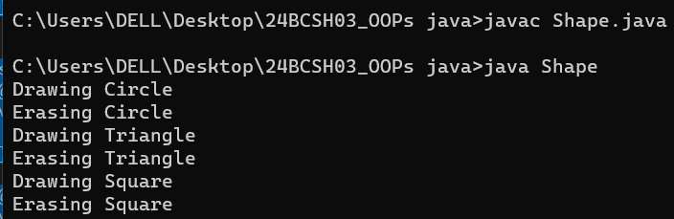
Q4. Define an abstract class named “Figure”, having data members dim1 and dim2. Extend this class to create two concrete classes named Rectangle and Triangle. Override the getArea() method in the sub classes. Invoke the getArea() method in the main method of another Driver class through the abstract class reference variable.
Code:
import java.util.Scanner;
abstract class Figure {
double dim1, dim2;
Figure(double d1, double d2) {
dim1 = d1;
dim2 = d2;
}
abstract double getArea();
}
class Rectangle extends Figure {
Rectangle(double length, double breadth) {
super(length, breadth);
}
@Override
double getArea() {
return dim1 * dim2;
}
}
class Triangle extends Figure {
Triangle(double base, double height) {
super(base, height);
}
@Override
double getArea() {
return 0.5 * dim1 * dim2;
}
}
public class Figure2 {
public static void main(String[] args) {
Scanner sc = new Scanner(System.in);
Figure f;
System.out.print("Enter length of Rectangle: ");
double length = sc.nextDouble();
System.out.print("Enter breadth of Rectangle: ");
double breadth = sc.nextDouble();
f = new Rectangle(length, breadth);
System.out.println("Area of Rectangle: " + f.getArea());
System.out.println();
System.out.print("Enter base of Triangle: ");
double base = sc.nextDouble();
System.out.print("Enter height of Triangle: ");
double height = sc.nextDouble();
f = new Triangle(base, height);
System.out.println("Area of Triangle: " + f.getArea());
sc.close();
}
}
Output:
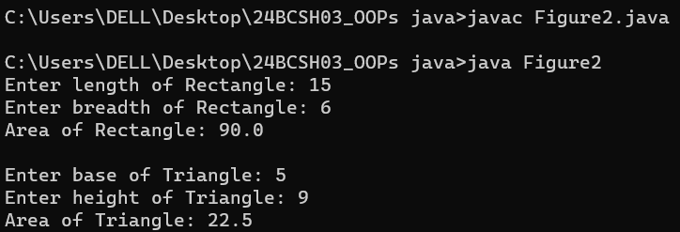

Q5. Create a class Point2D with the data member x and y coordinate. Use default and parameterised constructor to set the coordinate values and display() to show the coordinates. Create a subclass called Point3D which is derived from the superclass Point2D with data members z coordinate and has constructor to initialize the input and show() method to display the coordIna- tes. Test the methods of both the classes by creating objects in the main method of driver class.
Code:
import java.util.Scanner;
class Point2D {
int x, y;
Point2D() {
x = 0;
y = 0;
}
Point2D(int x, int y) {
this.x = x;
this.y = y;
}
void display() {
System.out.println("2D Point: (" + x + ", " + y + ")");
}
}
class Point3D extends Point2D {
int z;
Point3D() {
super();
z = 0;
}
Point3D(int x, int y, int z) {
super(x, y);
this.z = z;
}
void show() {
System.out.println("3D Point: (" + x + ", " + y + ", " + z + ")");
}
}
public class Point {
public static void main(String[] args) {
Scanner sc = new Scanner(System.in);
System.out.print("Enter X and Y coordinates for 2D Point: ");
int x2d = sc.nextInt();
int y2d = sc.nextInt();
Point2D p2d = new Point2D(x2d, y2d);
p2d.display();
System.out.println();
System.out.print("Enter X, Y and Z coordinates for 3D Point: ");
int x3d = sc.nextInt();
int y3d = sc.nextInt();
int z3d = sc.nextInt();
Point3D p3d = new Point3D(x3d, y3d, z3d);
p3d.show();
sc.close();
}
}
Output:
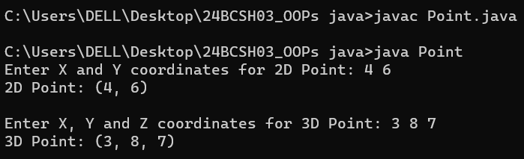

Q6. Create the classes as given in the below figure. Display the interest rate in the following format:
SBI Rate of Interest : 8
ICICI Rate of Interest : 7
AXIS Rate of Interest : 9
Code:
class Bank {
float getROI() {
return 0;
}
}
class SBI extends Bank {
@Override
float getROI() {
return 8;
}
}
class ICICI extends Bank {
@Override
float getROI() {
return 7;
}
}
class AXIS extends Bank {
@Override
float getROI() {
return 9;
}
}
public class ROI {
public static void main(String[] args) {
Bank b;
b = new SBI();
System.out.println("SBI Rate of Interest : " + b.getROI());
b = new ICICI();
System.out.println("ICICI Rate of Interest : " + b.getROI());
b = new AXIS();
System.out.println("AXIS Rate of Interest : " + b.getROI());
}
}
Output:
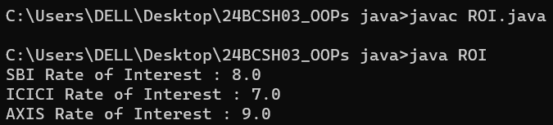

Q7. Create a class Person that has data member name. Use constructor to initialize name and display() to display name. Create a derived class Employee from Person class having private members empid. Using constructor initialize empid and have method display() to display empid. Create another derivedclass HourlyEmployee from Employee with private members hourlyRate and hoursWorked. Use constructor to initialize input and methods getGrossPay() that computes and returns the gross pay of the employee and display() to display the hourlyRate, hoursWorked and gross pay. Create a driver class to test the functionalities of the above classes and display output in the following format
Name : John Smith
EmpID : 7569
Hourly Rate : 100
Hours worked : 2000
Gross pay : 200000
Cdoe:
class Person {
String name;
Person(String name) {
this.name = name;
}
void display() {
System.out.println("Name : " + name);
}
}
class Emp extends Person {
private int empid;
Emp(String name, int empid) {
super(name);
this.empid = empid;
}
@Override
void display() {
super.display();
System.out.println("EmpID : " + empid);
}
int getEmpid() {
return empid;
}
}
class HourlyEmployee extends Emp {
private double hourlyRate;
private double hoursWorked;
HourlyEmployee(String name, int empid, double hourlyRate, double hoursWorked) {
super(name, empid);
this.hourlyRate = hourlyRate;
this.hoursWorked = hoursWorked;
}
double getGrossPay() {
return hourlyRate * hoursWorked;
}
@Override
void display() {
super.display();
System.out.println("Hourly Rate : " + hourlyRate);
System.out.println("Hours worked : " + hoursWorked);
System.out.println("Gross pay : " + getGrossPay());
}
}
public class Employee {
public static void main(String[] args) {
HourlyEmployee he = new HourlyEmployee("John Smith", 7569, 100, 2000);
he.display();
}
}
Output:
